Multiple choice section

|  |  |  |  |  |  |  |  |  |
| --- | --- | --- | --- | --- | --- | --- | --- | --- |
| Question | 1 | 2 | 3 | 4 | 5 | 6 | 7 | 8 |
| Answer | C | B | A | A | C | D | B | B |

Question 1 [6.1]

C



Question 2 [6.1]

B

58' = = 0.97

So = 12.97

22.07 + 12.97 = 35.04

Question 3 [6.2]

A

 = 10.9

Question 4 [6.2]

A

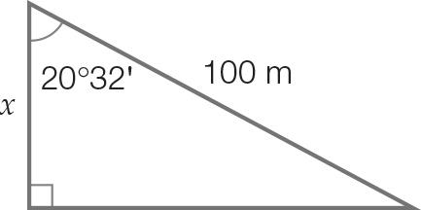

cos (20°32′) = 

x = 100 × cos (20°32′)

x = 93.65 (2 d.p.)

Question 5 [6.3]

C



Question 6 [6.4]

D

tan(26) = 

x = 30 × tan (26)

x = 14.63 (2 d.p)

Question 7 [6.5]

B

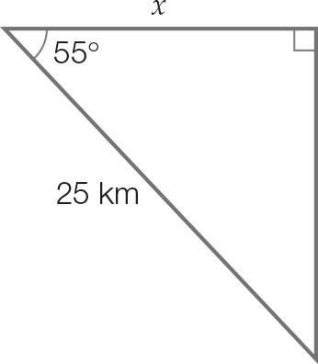

cos(55) = 

x = 25 × cos (55)

x = 14.3 km

Question 8 [6.5]

B





N60E is the compass bearing.

Multiple-choice total marks: 8

Short answer section

Question 9 2 marks [6.2]

|  |  |
| --- | --- |
|  |  |

Question 10 2 marks [6.3]

|  |  |
| --- | --- |
| Kite 1: | Kite 2: |

Question 11 3 marks [6.4]

After 3 seconds, the dog has run 18 m. The angle between the tree and the line of sight of the top of the tree to the dog:   


Angle of depression:



Question 12 3 marks [6.4]

Height from ground level to eye level:

570 cm + 13 cm = 583 cm

Let θ be the angle of elevation.



Question 13 4 marks [6.6]

|  |  |
| --- | --- |
| (a) Let θ be the angle line AB makes with the horizontal.   True bearing: 90 – 53.1 = 036.87T | (b) Let x be the length BC. Using Pythagoras’ theorem: |

Short answer total marks: 14

Extended response section

Question 14 6 marks [6.6]

Let x be the length of the first cable.



Let y be the length of the second cable.



Total length: 1059.45 + 1390.75 = 2450.20 cm

Round to the nearest cm = 2450 cm

Question 15 5 marks [6.5]

(a) 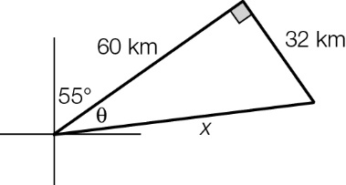  
  
Total: 60 + 32 + 68 = 160 km

(b)   
  
True bearing is 55 + 28.07 = 083.07T

Extended answer total marks: 11

TOTAL test marks: 33